**Module 2 Lesson #09: Simplifying Rational Expressions**

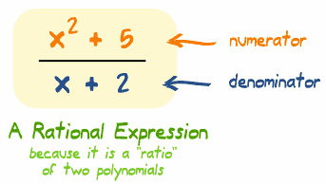

Learning Targets:

* I can identify and simplify a rational expression.
* I can multiply and divide rational expressions.

What is a ***rational expression***?

**Rational Expressions should be written in *simplest form* (which means the numerator and denominator have no common divisors).**

**In simplest form Not in simplest form**

**Domain Restrictions of Rational Expressions**

What does it mean for a fraction to be undefined?

For $\frac{3x}{x-5}$, $x≠$

For $\frac{x^{2}+3x+2}{x^{2}+x-2}$, $x≠$

**Simplifying Rational Expressions**

Something is different here…

1. $\frac{24x^{3}y^{2}}{-6x^{2}y^{3}}$ 3) $\frac{12-4x}{x^{2}-9}$
2. $\frac{x^{2}+7x+10}{x^{2}-3x-10}$ 4) $\frac{x^{3}-8}{x^{2}-4x+4}$

Multiplying Rational Expressions

1. $\frac{4x^{2}}{5y}∙\frac{7y}{12x^{4}}$ 2) $\frac{8y-4}{10y-5}∙\frac{5y-5}{3y-9}$

**Dividing Rational Expressions**

What is the quotient of $\frac{1}{2}÷\frac{1}{4}$?

$\frac{7x}{4y^{3}}÷\frac{21x^{3}}{8y}$

HOMEWORK:



$\frac{x^{2}+x-6}{x-5}∙\frac{x^{2}-25}{x^{2}+4x+3}$

2) $\frac{2x^{2}-3x-2}{2x^{2}+x}∙\frac{4x^{2}}{4-2x}$

3) $\frac{2-x}{x^{2}+2x+1}÷\frac{x^{2}+3x-10}{x^{2}-1}$

$$4) \frac{12x+4}{x^{2}+6x+8}÷\frac{3x^{2}-8x-3}{9-x^{2}}∙\frac{x^{2}-2x-8}{2x^{2}+6x}$$